**26. Hibernate-OneToMany-Unidirectional**

**One-to-Many Mapping**:

1. A course can have many reviews
2. This is an Uni-directional relationship

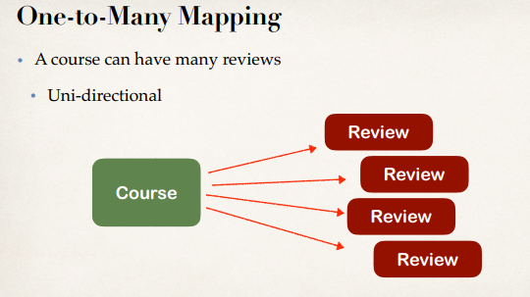

**Real-World Project Requirement**:

1. If you delete a course, also delete the reviews
2. Reviews without a course … have no meaning

**Table structure**:

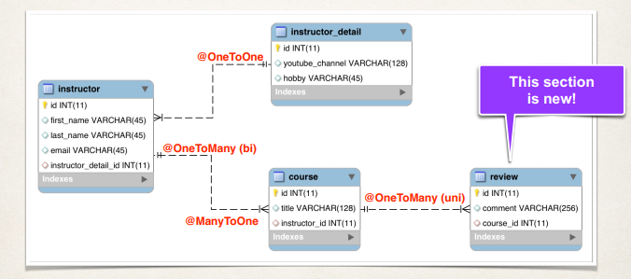

**Development Process**:

1. Prep Work - Define database tables
2. Create **Review** class
3. Update **Course** class
4. Create Main App

26. Hibernate-OneToMany-Unidirectional